Practical File Submission

Course Name: JavaScript Lab Course Code: T-3013 / 0705210508

Submitted by
Piyush Chopade 25070521509
Batch: 2024-28
Semester - V Section: C

Submitted to
Dr. Shreyas Rajendra Hole

Practical 1
Experiment Title: Demonstrate inline, internal, and external JavaScript; use console methods; create a webpage showing user info and a welcome message.
Software/Tools Required: VS Code , Web Browser

Experiment Program Code: Demo html file:
<!DOCTYPE html>
<html>
<head>
<title>JS Demo</title>
<style>
body {
background-color: #eef3ff; font-family: Arial, sans-serif; text-align: center;
padding: 40px;
}

h1 {
color: #1a5cff;
}
button {
background-color: #1a5cff; color: white;
border: none; padding: 10px 18px;

margin: 6px;
border-radius: 6px; font-size: 15px; cursor: pointer;
}

button:hover {
background-color: #0d3fb0;
}

#output {
margin-top: 20px; font-size: 16px; color: #333;
}
</style>
</head>
<body>

<h1>Welcome to my Webpage!</h1>
<p id="output"></p>

<!-- INLINE JS -->

<button onclick="console.log('Inline JS: Button clicked!')">Inline JS</button>

<!-- INTERNAL JS -->
<button id="internalBtn">Internal JS</button>

<!-- EXTERNAL JS -->
<button id="externalBtn">External JS</button>

<script>
// INTERNAL JS - shows welcome message and logs it document.getElementById("output").innerText = "Welcome! Today's date is " + new
Date().toDateString();
console.log("Internal JS: Page loaded, welcome message shown.");

document.getElementById("internalBtn").onclick = function () { console.log("Internal JS: Browser - " + navigator.userAgent); console.log("Internal JS: Platform - " + navigator.platform);
};
</script>
<script src="script.js"></script>

</body>
</html>

Output:
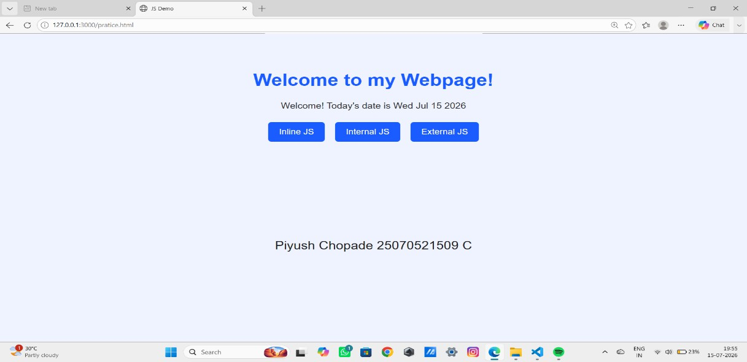

Case Study 01
Case Study Title:- Create a web page for college department and link the student information page with it and write a js program to display "Welcome to SIT Nagpur" in an alert box

Case Study Code: Department file (HTML):-
<!DOCTYPE html>
<html>
<head>
<title>Department Home</title>
<style>
body {
background-color: #f5f8ff; font-family: Arial, sans-serif;
margin: 0;
padding: 0;
}
header {
background-color: #1a5cff; color: white;
padding: 20px; text-align: center;
}
header h1 { margin: 0;
font-size: 26px;
}

header p {
margin: 5px 0 0; font-size: 14px;
}
.content {
max-width: 500px; margin: 30px auto; background-color: white; padding: 25px;
border-radius: 8px; border: 1px solid #ddd; text-align: center;
}
.content h2 { color: #1a5cff; cursor: pointer;
}

.content p { color: #444;
line-height: 1.6;
}
a.btn {
display: inline-block; margin-top: 10px; background-color: #1a5cff; color: white;
text-decoration: none; padding: 8px 16px;

border-radius: 5px; font-size: 14px;
}
a.btn:hover {
background-color: #0d3fb0;
}
footer {
text-align: center; color: #888;
font-size: 12px; margin: 30px 0 10px;
}
</style>
</head>
<body>
<header>
<h1>SIT Nagpur</h1>
<p>Department of Computer Science</p>
</header>

<div class="content">
<!-- INLINE JS -->

<h2 onclick="console.log('Inline JS: Department title clicked!')"> Welcome to our Department Page
</h2>

<p>Click the heading above to see an inline JS console message. This page also links to the student information page below.</p>
<a class="btn" href="student-info.html">View Student Information</a>
</div>
<footer>Made by a Student &middot; SIT Nagpur</footer>
<script>
// INTERNAL JS
console.log("Internal JS: Department page loaded successfully.");
</script>
<!-- EXTERNAL JS -->
<script src="script.js"></script>
</body>
</html>

Student Info (html):-
<!DOCTYPE html>
<html>
<head>
<title>Student Information</title>
<style>
body {
background-color: #f5f8ff; font-family: Arial, sans-serif; margin: 0;
padding: 0;
}
header {
background-color: #1a5cff;

color: white;
padding: 20px; text-align: center;
}
header h1 { margin: 0;
font-size: 24px;
}
.content {
max-width: 500px; margin: 30px auto; background-color: white; padding: 25px;
border-radius: 8px; border: 1px solid #ddd; text-align: center;
}
table {
margin: 15px auto; border-collapse: collapse; width: 100%;
}
td, th {
border: 1px solid #ddd; padding: 8px 12px; font-size: 14px;
}
th {
background-color: #eef3ff;

color: #1a5cff;
}
a.btn {
display: inline-block; margin-top: 15px; background-color: #1a5cff; color: white;
text-decoration: none; padding: 8px 16px; border-radius: 5px; font-size: 14px;
}
a.btn:hover {
background-color: #0d3fb0;
}
footer {
text-align: center; color: #888;
font-size: 12px; margin: 30px 0 10px;
}
</style>
</head>
<body>
<header>
<h1>Student Information</h1>
</header>

<div class="content">
<table>
<tr>
<th>Name</th>
<th>Roll No.</th>
<th>Branch</th>
</tr>
<tr>
<td>Your Name</td>
<td>101</td>
<td>Computer Science</td>
</tr>
</table>

<a class="btn" href="department.html">Back to Department Home</a>
</div>

<footer>Made by a Student &middot; SIT Nagpur</footer>
<script>
// INTERNAL JS
console.log("Internal JS: Student information page loaded.");
</script>
</body>
</html>

Output :
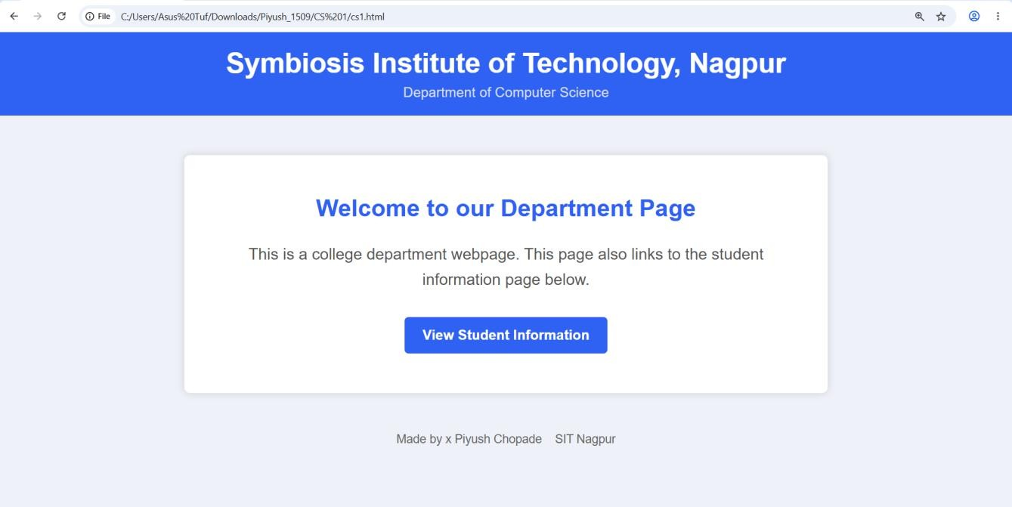
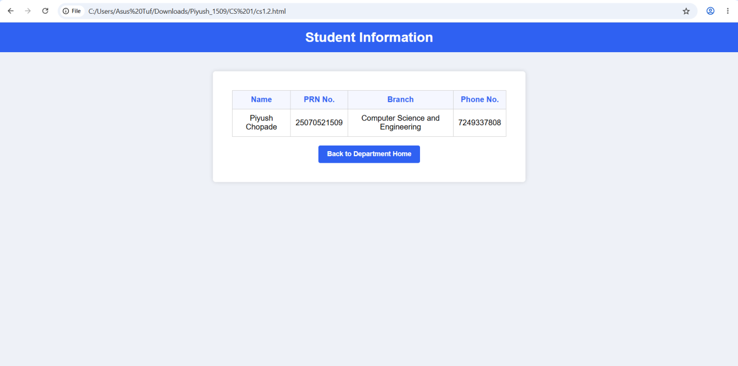

Result / Conclusion:- Hence we have created a basic html page with javascript to show student information and and website login page.

Practical 02
Aim:- Use var, let, const, and demonstrate basic features like template literals and destructuring; build a billing calculator with user input.
Software/Tools Required: VS Code , Web Browser

Experiment program code: Calculator.html:-
<!DOCTYPE html>
<html>
<head>
<title>Billing Calculator</title>
</head>
<body>
<h2>Billing Calculator</h2>

<script>
// const example const GST = 0.18;

//user Input
var customerName = prompt("Enter Customer Name:"); var productName = prompt("Enter Product Name:");

// var example
var quantity = Number(prompt("Enter Quantity:")); let price = Number(prompt("Enter Price per Item:"));

//Calculations
let total = quantity * price;

let gstAmount = total * GST;
let finalBill = total + gstAmount;

//Object const bill = {
customer: customerName, product: productName, quantity,
price, total,
gstAmount, finalBill
};

//Destructuring const {
customer, product, gstAmount: gst, finalBill: amountz
} = bill;

//Output using Template Literals document.write(`<h3>Billing Receipt</h3>`); document.write(`<p>Customer: ${customer}</p>`); document.write(`<p>product: ${product}</p>`); document.write(`<p>Quantity: ${quantity}</p>`); document.write(`<p>Price per Item: ₹${price}</p>`); document.write(`<p>GST (18%): ₹${gst.toFixed(2)}</p>`);
document.write(`<p>Final Bill: ₹${amount.toFixed(2)}</p>`);

</script>
</body>
</html>

Output :

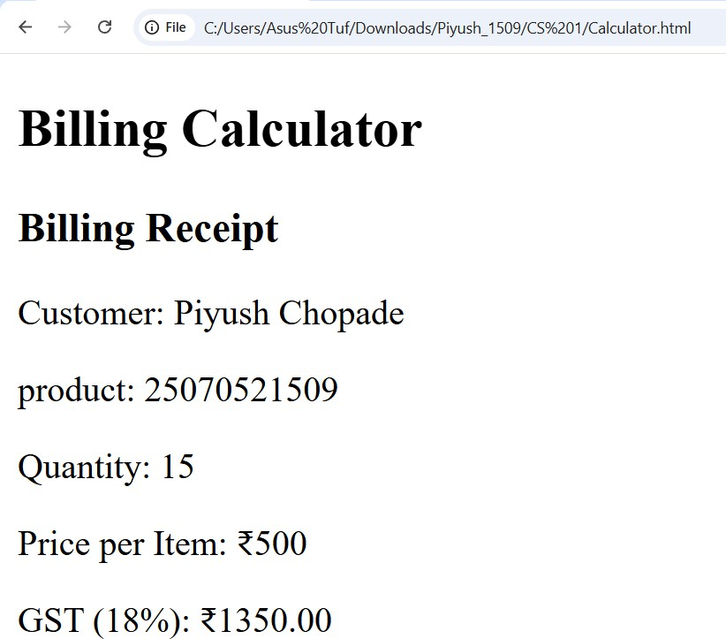

Case Study 02
Case Study Title:- Develop the webpage for an online shopping website with using HTML,CSS and HTML5 tags
Software/Tools Used:- VScode , Web Browser

Code:-
<!DOCTYPE html>
<html>
<head>
<title>Online Shopping - Bill Calculator</title>
</head>
<body>

<h1>Online Shopping Store - Bill Calculator</h1>

<form id="billForm">

<label for="custName">Customer Name</label><br>
<input type="text" id="custName" required><br><br>

<label for="mobile">Mobile Number</label><br>
<input type="tel" id="mobile" required><br><br>

<label for="invoice">Invoice Number</label><br>
<input type="text" id="invoice" required><br><br>

<label for="product">Product Name</label><br>

<input type="text" id="product" required><br><br>

<label for="quantity">Quantity (in Kg)</label><br>
<input type="number" id="quantity" step="0.1" required><br><br>

<label for="rate">Rate per Kg (Rs.)</label><br>
<input type="number" id="rate" step="0.01" required><br><br>

<label for="discount">Discount (%)</label><br>
<input type="number" id="discount" step="0.1" value="0"><br><br>

<label for="gst">GST (%)</label><br>
<input type="number" id="gst" step="0.1" value="0"><br><br>

<label for="packing">Packing Charges (Rs.)</label><br>
<input type="number" id="packing" step="0.01" value="0"><br><br>

<label for="payment">Payment Mode</label><br>
<select id="payment">
<option value="Cash">Cash</option>
<option value="Card">Card</option>
<option value="UPI">UPI</option>
</select><br><br>

<label for="membership">Membership</label><br>
<select id="membership">

<option value="No">No</option>
<option value="Yes">Yes</option>
</select><br><br>

<button type="button" onclick="calculateBill()">Calculate Bill</button>
</form>

<div id="result"></div>

<script>
// INTERNAL JS (inbuilt script inside the HTML file)

function calculateBill() {
// Reading input values - all inputs return strings, so we convert them
// using Number() to demonstrate type conversion
let custName = document.getElementById("custName").value; // string let mobile = document.getElementById("mobile").value; // string
let invoice = document.getElementById("invoice").value; // string let product = document.getElementById("product").value; // string

let quantity = Number(document.getElementById("quantity").value); // number let rate = Number(document.getElementById("rate").value); // number
let discount = Number(document.getElementById("discount").value); // number let gst = Number(document.getElementById("gst").value); // number
let packing = Number(document.getElementById("packing").value); // number

let payment = document.getElementById("payment").value; // string
let membership = document.getElementById("membership").value === "Yes"; // boolean

// Basic validation
if (!custName || !mobile || !invoice || !product || quantity <= 0 || rate <= 0) { console.error("Validation failed: Please fill all required fields correctly."); alert("Please fill all required fields with valid values.");
return;
}

// Calculation
const subtotal = quantity * rate;
const discountAmount = (subtotal * discount) / 100; const afterDiscount = subtotal - discountAmount; const gstAmount = (afterDiscount * gst) / 100;

// Extra membership discount (const used since this value won't change) const membershipDiscount = membership ? afterDiscount * 0.05 : 0;

let totalBill = afterDiscount + gstAmount + packing - membershipDiscount;

console.log("----- Bill Calculation ");
console.log("Customer: " + custName); console.log("Subtotal: Rs. " + subtotal.toFixed(2));
console.log("Discount Amount: Rs. " + discountAmount.toFixed(2)); console.log("GST Amount: Rs. " + gstAmount.toFixed(2));

console.log("Membership Discount: Rs. " + membershipDiscount.toFixed(2)); console.log("Total Bill: Rs. " + totalBill.toFixed(2));

// Display result document.getElementById("result").innerHTML =
"<hr>" +
"<p><strong>Customer:</strong> " + custName + " (" + mobile + ")</p>" + "<p><strong>Invoice No:</strong> " + invoice + "</p>" + "<p><strong>Product:</strong> " + product + " (" + quantity + " Kg)</p>" + "<p><strong>Subtotal:</strong> Rs. " + subtotal.toFixed(2) + "</p>" + "<p><strong>Discount:</strong> Rs. " + discountAmount.toFixed(2) + "</p>" + "<p><strong>GST:</strong> Rs. " + gstAmount.toFixed(2) + "</p>" + "<p><strong>Packing Charges:</strong> Rs. " + packing.toFixed(2) + "</p>" +
"<p><strong>Membership Discount:</strong> Rs. " + membershipDiscount.toFixed(2) + "</p>" +
"<p><strong>Payment Mode:</strong> " + payment + "</p>" + "<p><strong>Total Bill: Rs. " + totalBill.toFixed(2) + "</strong></p>";
}
</script>

</body>
</html>

Output :

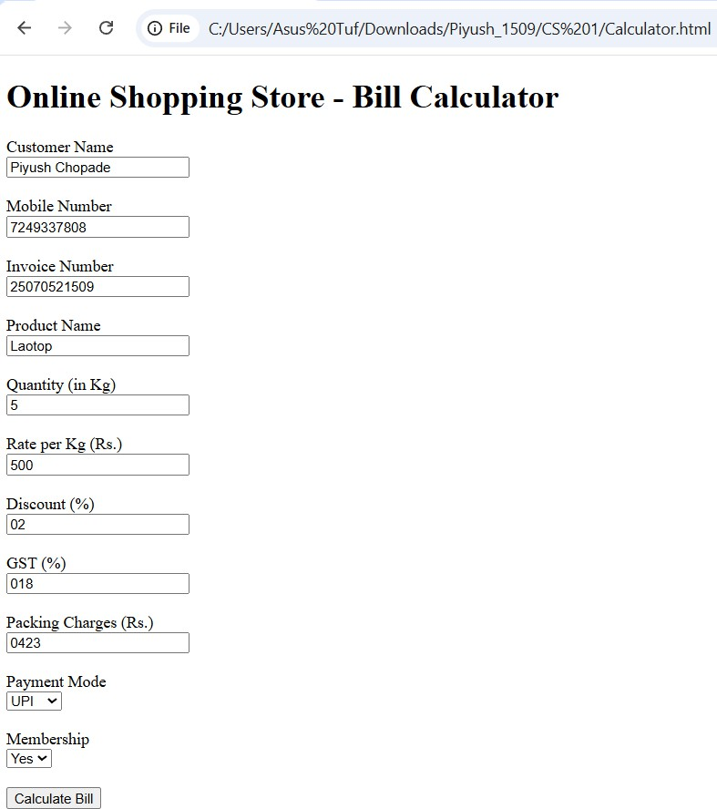

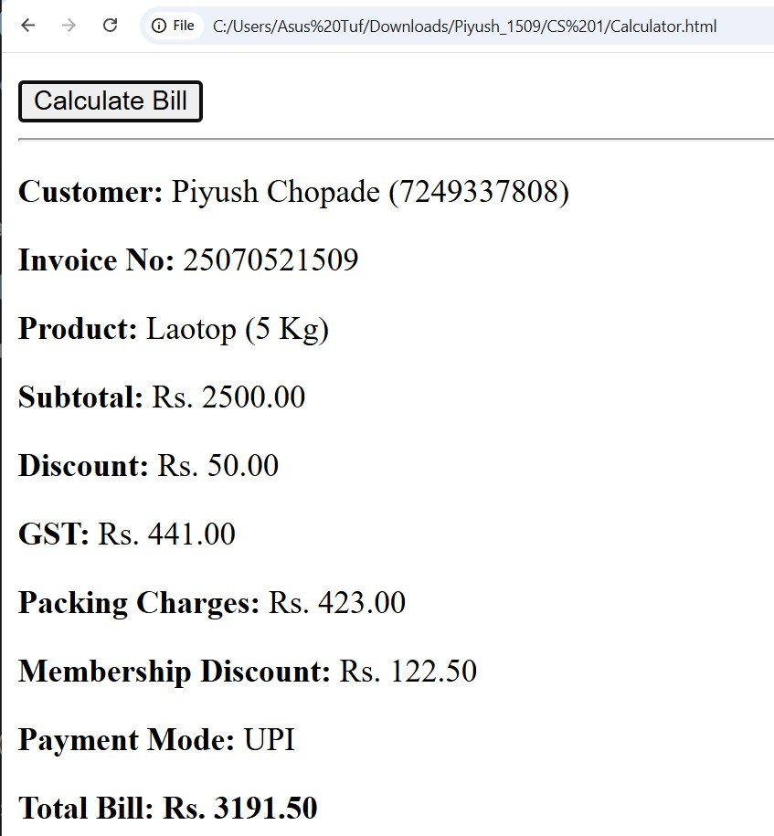

Practical 3
Aim:- Implement control structures and form validation; create a grading system based on user-entered marks.
Software/Tools Required: VS Code , Web Browser

Experiment program code:
Student Marks and grade:-
<html>
<head>
<title>Piyush Chopade</title>
</head>
<body>
<h2>Piyush Chopade 1509</h2>
<h2>Student Grading System</h2>
<h3>Enter marks:</h3>
<input type = 'number' id = 'marks'></input>
<button onClick="checkGrade()">Submit</button>
<p id = 'result'></p>
<script>
function checkGrade(){
var marks = document.getElementById("marks").value; if( marks == ""){
alert("Please Enter marks!!"); return;
}
if(marks<0 || marks> 100){

alert("Enter marks between 0 and 100");
}
if(marks>=90){ grade = 'A';
}
else if(marks >=80){ grade = "B";
}
else if(marks>=70){ grade = "C";
}
else if(marks >=50){ grade = "D"
}
else{ grade = "Fail";
}
document.getElementById("result").innerHTML = "Marks =" + marks + "<br>Grade = "+ grade;
}
</script>
</body>
</html>

Output :

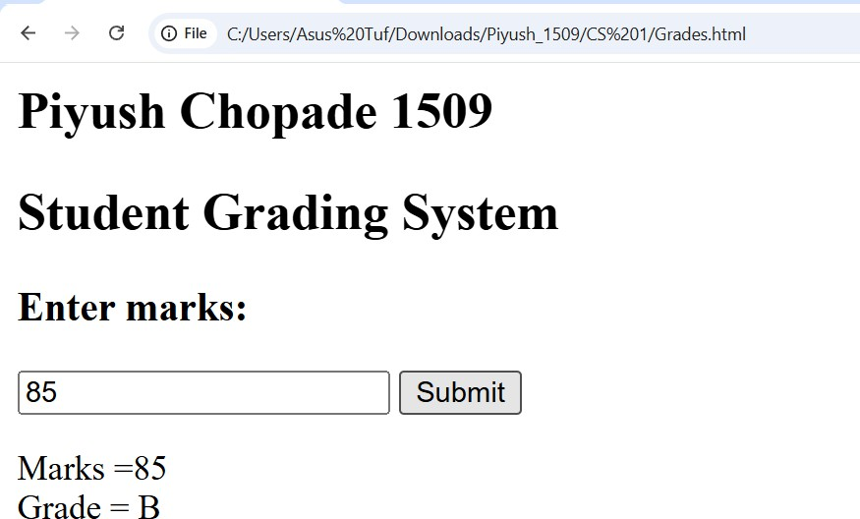

Case Study 03
Case Study Title:- Scholarship Eligibilty: A college awards scholarship based on marks Below 50:- Not eligible
50-69:- Bronze Scholarship
70-84:- Silver Scholarship
85-94:- Gold Scholarship
95-100:- Platinum Scholarship
Software/Tools Used:- VScode , Web Browser

Case Study Code:-
<html>
<head>
<title>Scholarship Eligibility</title>
<style>
body {
font-family: Arial, sans-serif; background-color: #f2f2f2; text-align: center;
padding: 40px;
}
h2 {
color: #c21321af; margin: 5px 0;
}

input {

}

padding: 8px; font-size: 15px; margin-top: 10px;
border: 1px solid #c0e61b; border-radius: 4px;

button {
display: block; margin: 15px auto 0; padding: 8px 20px; font-size: 15px;
background-color: #1a5cff; color: white;
border: none; border-radius: 4px; cursor: pointer;
}
button:hover {
background-color: #0d3fb0;
}
#result {
margin-top: 20px; font-size: 17px; color: #333;
}

</style>
</head>
<body>
<h2>Piyush Chopade 2507051509</h2>
<h2>Scholarship Eligibility System</h2>
<h3>Enter marks:</h3>
<input type='number' id='marks'></input>
<button onClick="checkScholarship()">Submit</button>
<p id='result'></p>
<script>
function checkScholarship(){
var marks = document.getElementById("marks").value; if( marks == ""){
alert("Please Enter marks!!"); return;
}
if(marks<0 || marks> 100){
alert("Enter marks between 0 and 100"); return;
}
if(marks>=95){
scholarship = "Platinum Scholarship";
}
else if(marks>=85){
scholarship = "Gold Scholarship";
}

else if(marks>=70){
scholarship = "Silver Scholarship";
}
else if(marks>=50){
scholarship = "Bronze Scholarship";
}
else{
scholarship = "Not Eligible";
}
document.getElementById("result").innerHTML = "Marks = " + marks + "<br>Scholarship = " + scholarship;
}
</script>
</body>
</html>

Output :
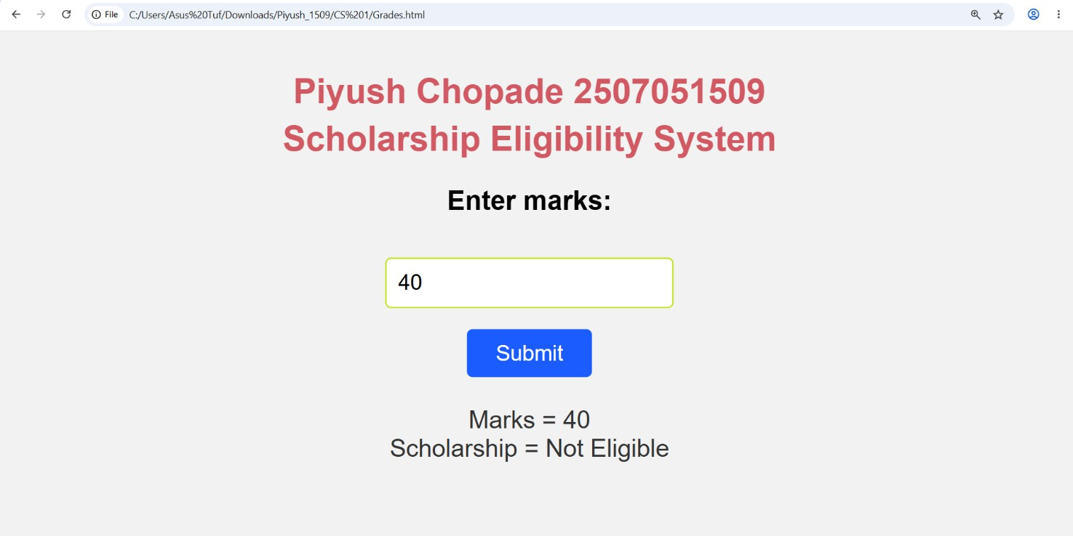

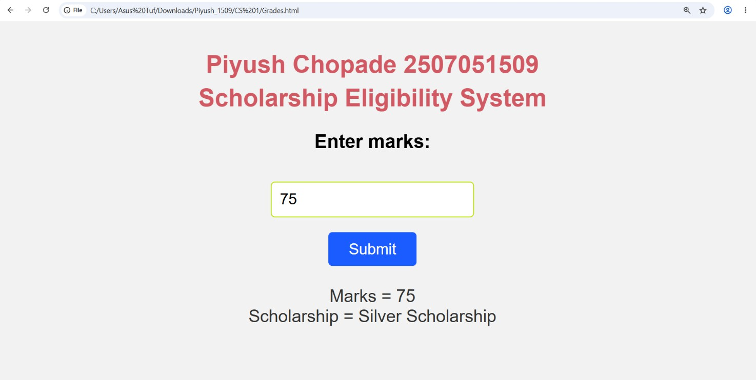

Practical 4
Aim:- Use function types ,scope , and closure; apply try catch ;build a palindrome checker
Software/Tools Required: VS Code , Web Browser

Experiment program code:
Palindrome checker:-
<!DOCTYPE html>
<html lang="en">
<head>
<meta charset="UTF-8">
<meta name="viewport" content="width=device-width, initial-scale=1.0">
<title>Palindrome Checker</title>
<style>
body {
font-family: Arial, sans-serif; background: #f4f4f4;
text-align: center; margin-top: 50px;
}
.container { width: 350px; margin: auto;
background: white; padding: 20px; border-radius: 10px;
box-shadow: 0 0 10px gray;
}
input {
width: 90%;

padding: 10px; margin: 10px;
}
button {
padding: 10px 20px; cursor: pointer;
}
h3 {
color: blue;
}
</style>
</head>
<body>

<div class="container">
<h2>Piyush Chopade 25070521509</h2>
<h2>Palindrome Checker</h2>

<input type="text" id="word" placeholder="Enter a word">

<button onclick="checkPalindrome()">Check</button>

<h3 id="result"></h3>
</div>

<script>

// Global Scope
let appName = "Palindrome Checker";

// Function Declaration function cleanString(str) {
return str.toLowerCase().replace(/[^a-z0-9]/g, "");
}

// Function Expression
const reverseString = function(str) { return str.split("").reverse().join("");
};

// Closure
function counter() { let count = 0;

return function() { count++;
return count;
};
}

const checkCount = counter();

// Arrow Function
const isPalindrome = (str) => { return str === reverseString(str);
};

// Main Function
function checkPalindrome() { try {

let input = document.getElementById("word").value;

// Local Scope
let text = cleanString(input);

if (text === "") {
throw "Please enter some text.";
}

let result = isPalindrome(text)
? `"${input}" is a Palindrome ⬛ `
: `"${input}" is NOT a Palindrome +`;

result += `<br>Checks Performed: ${checkCount()}`; document.getElementById("result").innerHTML = result;
} catch(error) {

document.getElementById("result").innerHTML =
`<span style="color:red;">Error: ${error}</span>`;

}

finally {
console.log(appName + " executed.");
}
}
</script>
</body>
</html>

Output :
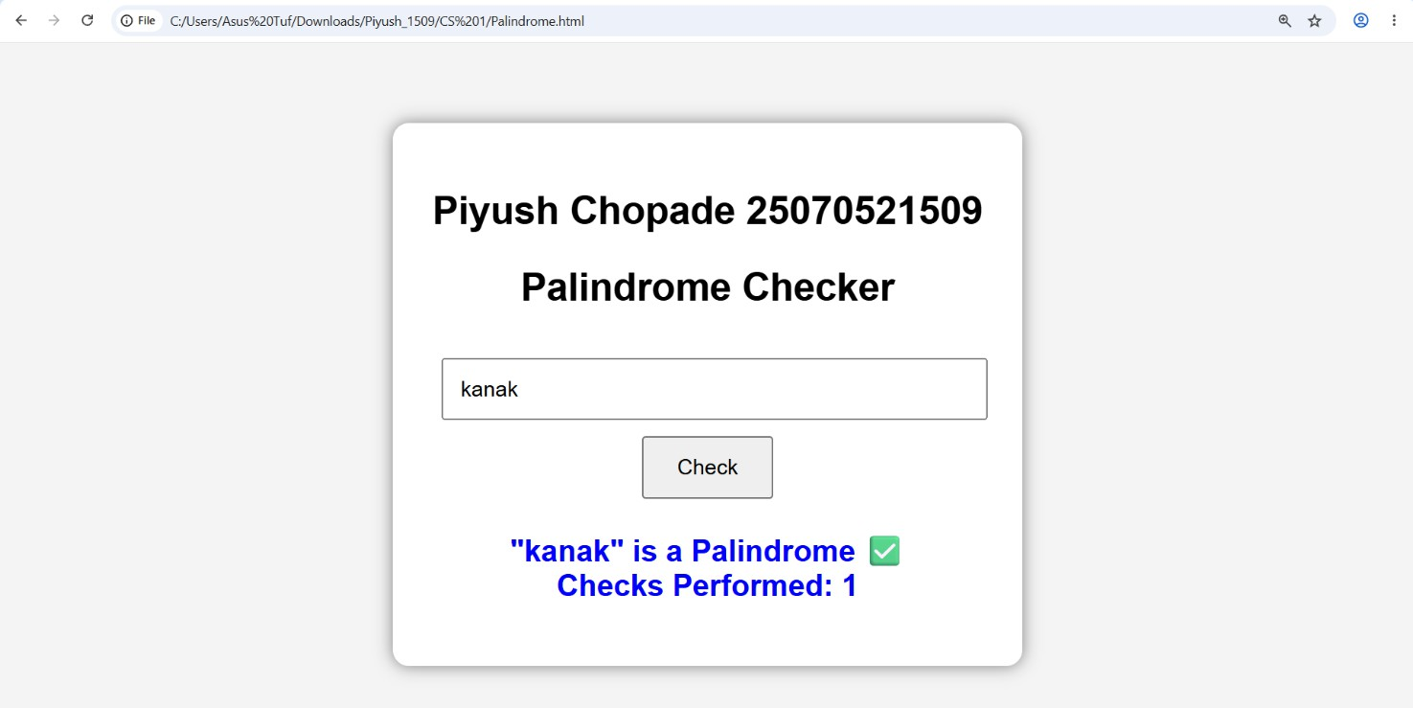

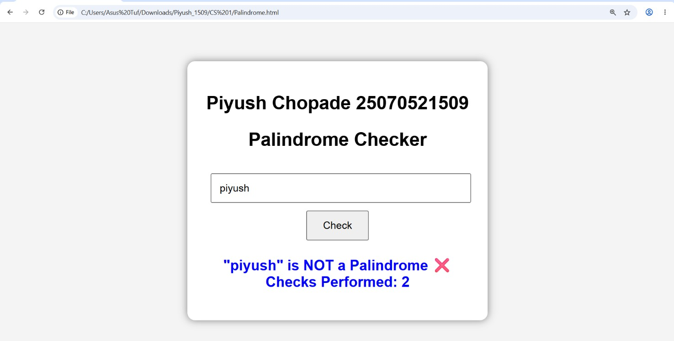

Case Study 04

Real-Time Case Study: ATM Card PIN Verification Using JavaScript Functions
Case Study An ATM system verifies whether a customer's PIN is a palindrome. If the PIN reads the same forward and backward, the bank displays a special security message. To implement this, create a function to reverse the entered PIN number and another function to check whether it is a palindrome. Use function declaration, function expression, arrow function, and demonstrate scope concepts
Software/Tools Used:- VScode , Web Browser

Case Study Code:-
<html>
<head>
<title>ATM PIN Verification</title>
<style>
body {
font-family: Arial, sans-serif; background-color: #f2f2f2; text-align: center;
padding: 40px;
}
h2 {
color: #1a5cff; margin: 5px 0;
}
input {
padding: 8px;

font-size: 15px;
margin-top: 10px; border: 1px solid #ccc; border-radius: 4px;
}
button {
display: block; margin: 15px auto 0; padding: 8px 20px; font-size: 15px;
background-color: #1a5cff; color: white;
border: none; border-radius: 4px; cursor: pointer;
}
button:hover {
background-color: #0d3fb0;
}
#result {
margin-top: 20px; font-size: 17px; color: #333;
}
</style>
</head>

<body>
<h2>Piyush Chopade 25070521509</h2>
<h2>ATM Card PIN Verification</h2>
<h3>Enter your 6-digit PIN:</h3>
<input type='text' id='pin' maxlength="6"></input>
<button onClick="verifyPin()">Submit</button>
<p id='result'></p>

<script>
// FUNCTION DECLARATION
// Reverses the entered PIN function reversePin(pin) {
return pin.split("").reverse().join("");
}

// FUNCTION EXPRESSION
// Checks whether the PIN is a palindrome (reads same forward and backward) var isPalindrome = function(pin) {
var reversed = reversePin(pin); // uses the function declared above return pin === reversed;
};

// ARROW FUNCTION
// Displays the security message based on the result var getMessage = (palindromeCheck) => {
if (palindromeCheck) {

return "Security Alert: Your PIN is a palindrome!";
} else {
return "PIN verified. No special security message.";
}
};

// MAIN FUNCTION (called on button click)
// MAIN FUNCTION (called on button click) function verifyPin() {
var pin = document.getElementById("pin").value; // local scope variable

if (pin == "" || pin.length !== 6 || isNaN(pin)) { alert("Please enter a valid 6-digit PIN!"); return;
}

var reversed = reversePin(pin);
var palindromeCheck = isPalindrome(pin);
var message = getMessage(palindromeCheck);

// Alert user if the PIN is a palindrome if (palindromeCheck) {
alert(" ı. Security Alert!\nYour PIN is a palindrome.\nFor better security, please change your ATM PIN.");
}

document.getElementById("result").innerHTML = "PIN entered = " + pin + "<br>" +
"Reversed PIN = " + reversed + "<br>" + message;
}
</script>
</body>

</html>
Output :

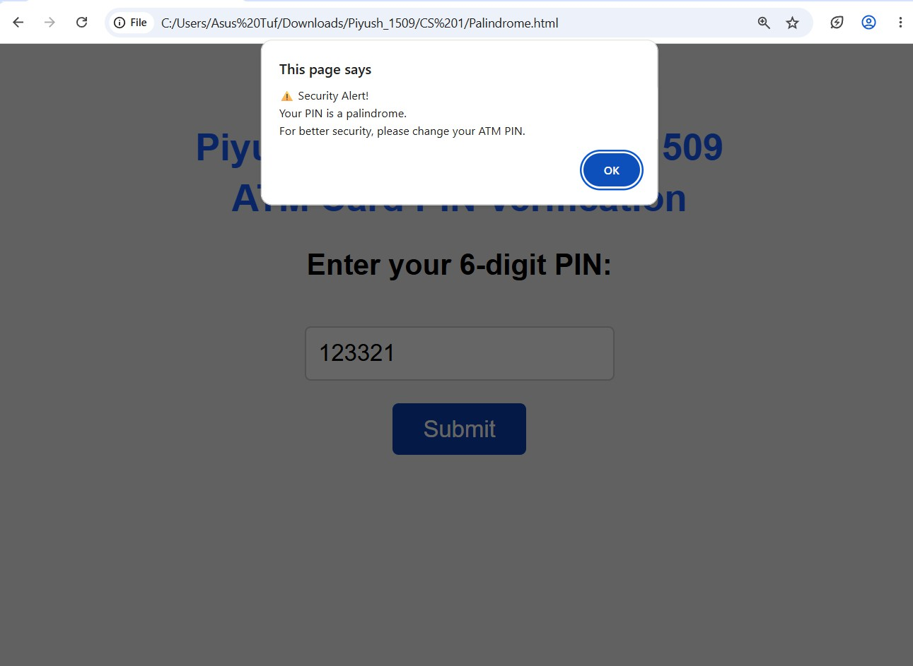

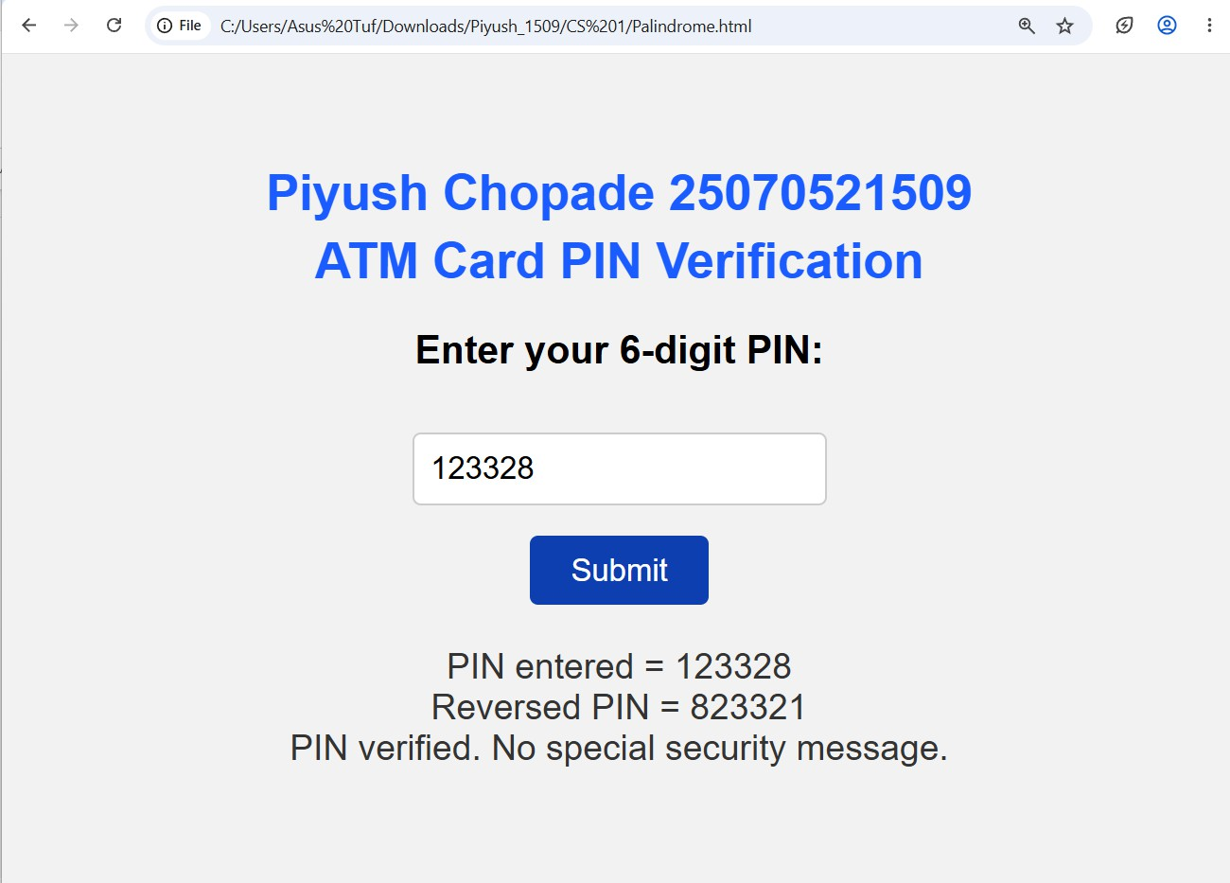

Practical -05

Title: Apply Array Methods and Object Handling; Create a Cart Total Calculator with Discount Logic.

Software/Tools Required: VS Code , Web Browser
Experiment program code:
<!DOCTYPE html>
<html lang="en">
<head>
<meta charset="UTF-8" />
<meta name="viewport" content="width=device-width, initial-scale=1.0" />
<title>Discount Calculator for Stationery Shop</title>
<style>
body {
font-family: Arial, sans-serif;
margin: 24px;
color: #333;
}
label {
margin-right: 8px;
}
input {
width: 130px;
padding: 6px;
margin-right: 8px;
}
button {
padding: 6px 12px;
cursor: pointer;
}
.results {
margin-top: 18px;
max-width: 400px;
}
.summary-card {
border: 1px solid #ddd;
padding: 12px;
border-radius: 6px;
background: #fafafa;
}
.summary-card p {
margin: 6px 0;
}
.error {
color: #c00;
}
table {
width: 100%;
border-collapse: collapse;
margin-top: 10px;
}
th, td {
border: 1px solid #ccc;
padding: 6px;
text-align: left;
}
</style>
</head>
<body>

<h2>Stationery Shop Discount Calculator</h2>

<!-- Input for product name -->
<label for="product">Product:</label>
<input type="text" id="product" placeholder="Product name" />

<!-- Input for product price -->
<label for="price">Price:</label>
<input type="number" id="price" placeholder="Price" />

<button onclick="addProduct()">Add Product</button>

<!-- List of added products -->
<h3>Products:</h3>
<table id="productList">
<thead>
<tr>
<th>Product</th>
<th>Price</th>
<th>Action</th>
</tr>
</thead>
<tbody>
<!-- Products will appear here -->
</tbody>
</table>

<!-- Button to calculate discount -->
<button onclick="calculateTotal()">Calculate Total & Discount</button>

<div class="results" id="results"></div>

<script>
const products = [];

function addProduct() {
const productInput = document.getElementById('product');
const priceInput = document.getElementById('price');

const productName = productInput.value.trim();
const productPrice = parseFloat(priceInput.value);

if (!productName) {
alert('Please enter a product name.');
return;
}
if (isNaN(productPrice) || productPrice <= 0) {
alert('Please enter a valid positive price.');
return;
}

products.push({ name: productName, price: productPrice });
updateProductList();

// Clear inputs
productInput.value = '';
priceInput.value = '';
}

function updateProductList() {
const tbody = document.getElementById('productList').getElementsByTagName('tbody')[0];
tbody.innerHTML = '';

products.forEach((prod, index) => {
const row = tbody.insertRow();
row.insertCell(0).innerText = prod.name;
row.insertCell(1).innerText = prod.price.toFixed(2);
const actionCell = row.insertCell(2);
const deleteBtn = document.createElement('button');
deleteBtn.innerText = 'Remove';
deleteBtn.onclick = () => {
products.splice(index, 1);
updateProductList();
};
actionCell.appendChild(deleteBtn);
});
}

function getAutoDiscount(amount) {
if (amount >= 2000) return 30;
if (amount >= 1000) return 20;
return 0;
}

function calculateTotal() {
const resultsDiv = document.getElementById('results');

if (products.length === 0) {
resultsDiv.innerHTML = "<p class='error'>Please add some products first.</p>";
return;
}

const totalAmount = products.reduce((sum, prod) => sum + prod.price, 0);
const discountPercentage = getAutoDiscount(totalAmount);
const discountAmount = (totalAmount * discountPercentage) / 100;
const finalAmount = totalAmount - discountAmount;

resultsDiv.innerHTML = `
<div class="summary-card">
<h3>Order Summary</h3>
<p>Total products: ${products.length}</p>
<p>Total amount: ${totalAmount.toFixed(2)}</p>
<p>Discount applied: <strong>${discountPercentage}%</strong></p>
<p>Discount amount: ${discountAmount.toFixed(2)}</p>
<p><strong>Final amount after discount: ${finalAmount.toFixed(2)}</strong></p>
</div>
`;
}
</script>

</body>
</html>
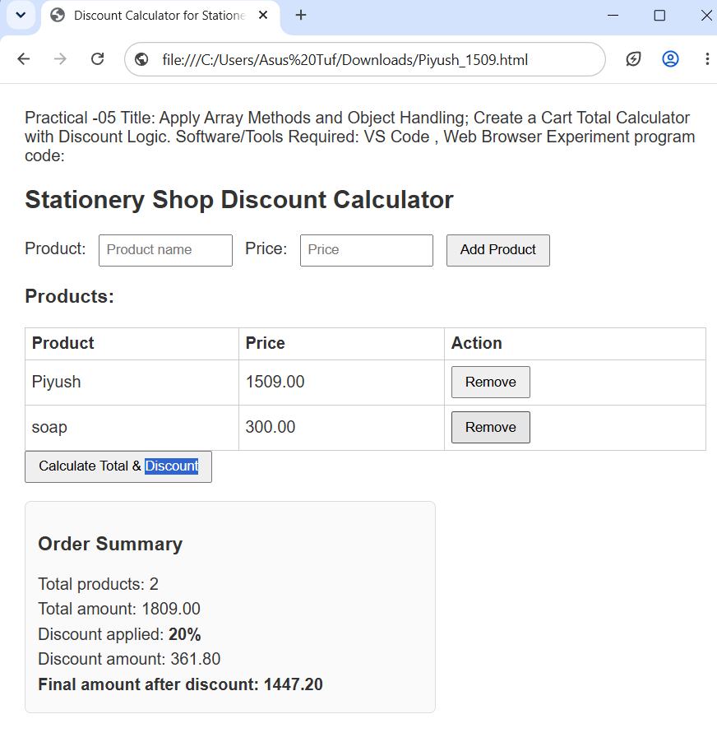

RESULT/CONCLUSION:
Thus, the experiment demonstrates the use of JavaScript arrays, objects, array methods, and conditional statements to calculate a shopping cart total and apply discounts. It provides a basic understanding of data handling and calculation using JavaScript.

